Lab assignment - 1.4 2303A51940 8-1-26
TASK - 0

Install and configure GitHub Copilot in VS Code. Take screenshots of each step.
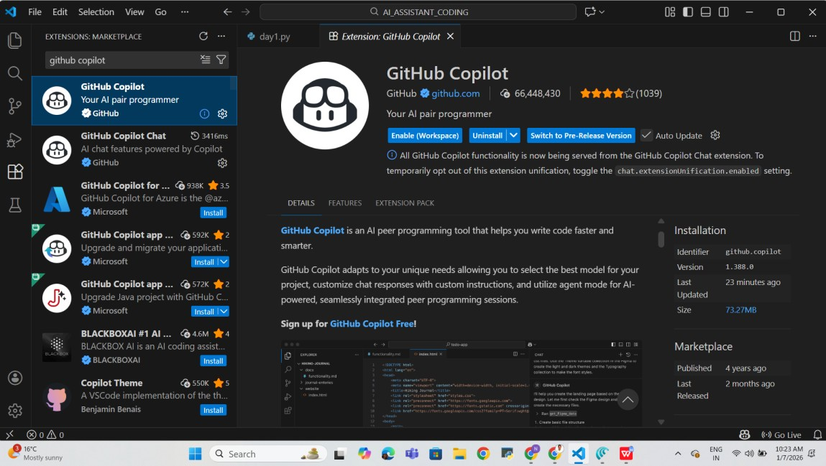

Task 1: AI-Generated Logic Without Modularization (Prime Number Check
Without Functions)
❖ Scenario
➢ You are developing a basic validation script for a numerical learning application.
❖ Task Description
Use GitHub Copilot to generate a Python program that:
- Checks whether a given number is prime
- Accepts user input
- Implements logic directly in the main code
- Does not use any user-defined functions
❖ Expected Output
- Correct prime / non-prime result
- Screenshots showing Copilot-generated code suggestions
- Sample inputs and outputs

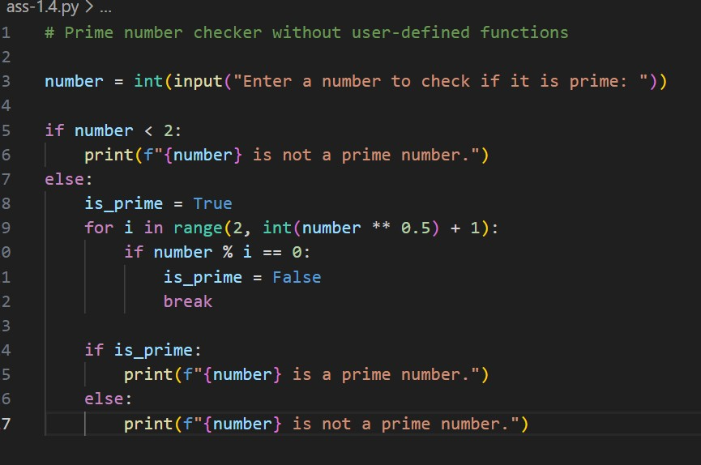

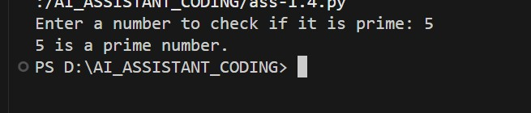

Task 2: Efficiency & Logic Optimization (Cleanup)
- Scenario
The script must handle larger input values efficiently.
- Task Description
Review the Copilot-generated code from Task 1 and improve it by:
- Reducing unnecessary iterations
- Optimizing the loop range (e.g., early termination) ➢ Improving readability ➢ Use Copilot prompts like:
▪ “Optimize prime number checking logic” ▪ “Improve efficiency of this code” Hint:
Prompt Copilot with phrases like
“optimize this code”, “simplify logic”, or “make it more readable”
❖ Expected Output
- Original and optimized code versions
- Explanation of how the improvements reduce time complexity
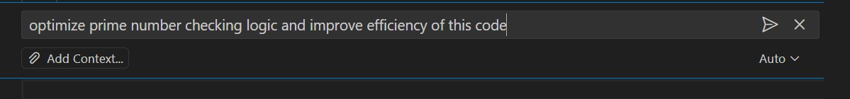

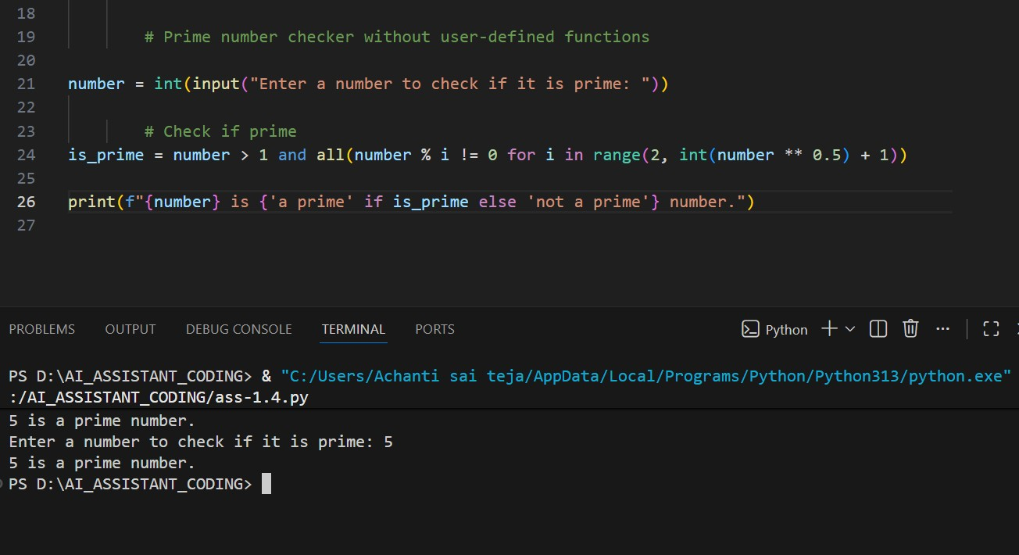

The optimization checks divisibility only up to √n instead of n, reducing unnecessary iterations.
This works because any composite number must have a factor less than or equal to √n.
Early termination using break or all() stops execution as soon as a divisor is found. Thus, time complexity improves from O(n) to O(√n), with best case O(1).

Task 3: Modular Design Using AI Assistance (Prime Number Check Using
Functions)
- Scenario
The prime-checking logic will be reused across multiple modules.
- Task Description
Use GitHub Copilot to generate a function-based Python program that:
- Uses a user-defined function to check primality
- Returns a Boolean value
- Includes meaningful comments (AI-assisted)
❖ Expected Output
- Correctly working prime-checking function
- Screenshots documenting Copilot’s function generation
- Sample test cases and outputs

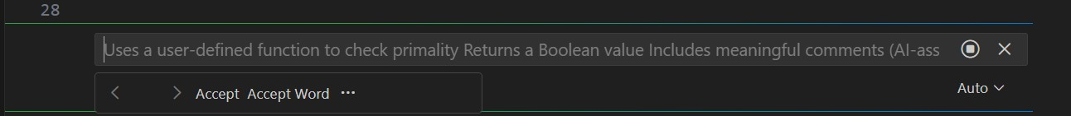

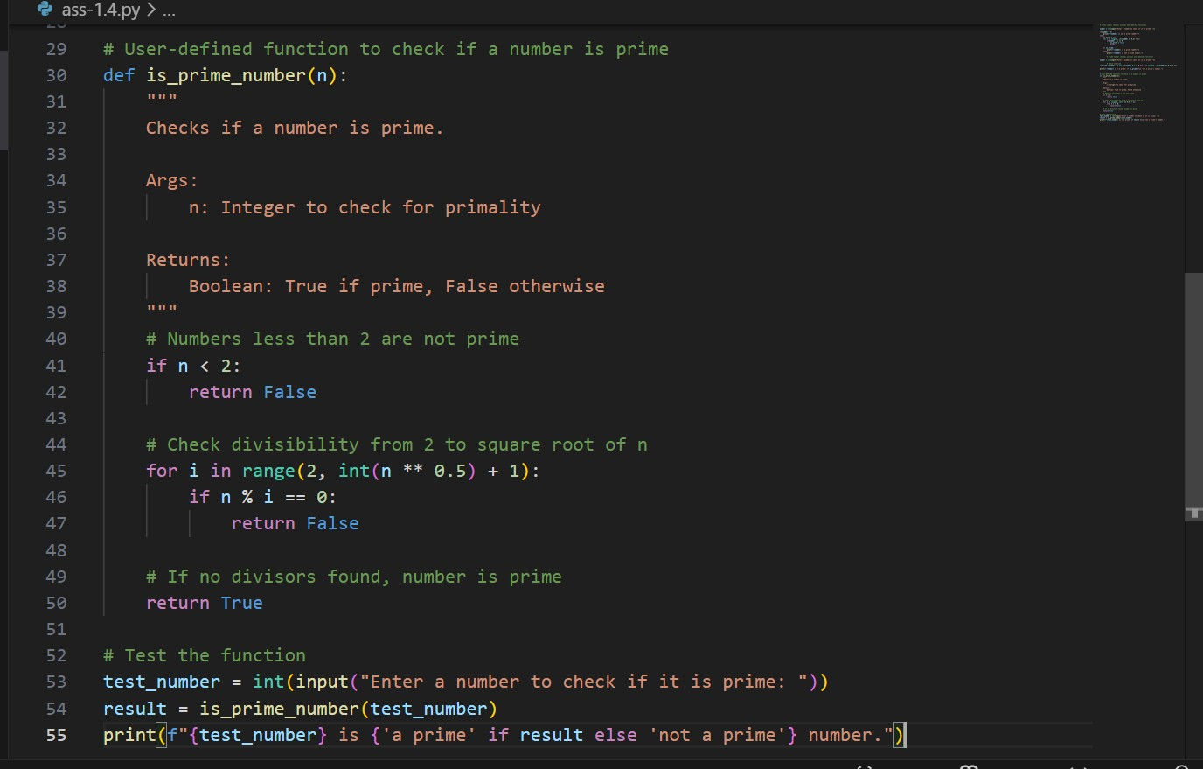

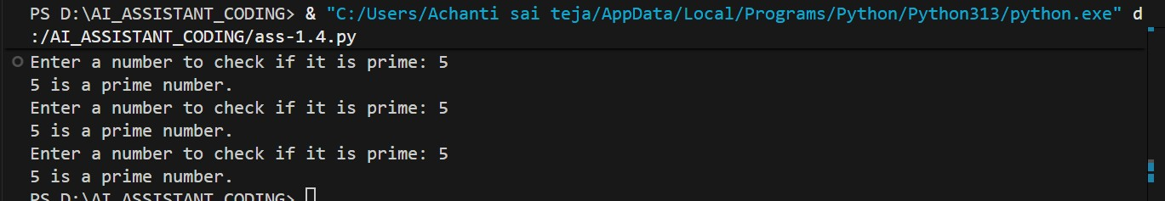

Task 4: Comparative Analysis –With vs Without Functions
- Scenario
You are participating in a technical review discussion.
- Task Description
Compare the Copilot-generated programs:
- Without functions (Task 1) ➢ With functions (Task 3) ➢ Analyze them based on:
- Code clarity
- Reusability
- Debugging ease
- Suitability for large-scale applications
❖ Expected Output
Comparison table or short analytical report

Comparison Report of the 3 Prime Number Checker Codes Code 1 – Loop with flag and break:
Uses a loop up to √n and stops early when a divisor is found. Efficient and easy to understand. Time complexity is O(√n).
Code 2 – all() with generator expression:
Also checks up to √n but uses Python’s built-in all() with short-circuiting. More concise and Pythonic, same O(√n) time complexity, slightly better readability.
Code 3 – User-defined function (is_prime_number)
Encapsulates logic in a function, improving reusability and modularity. Performance is the same (O(√n)), best suited for larger programs or repeated checks.
Overall Conclusion:
All three have the same time complexity (O(√n)). Code 2 is the most concise, Code 1 is beginnerfriendly, and Code 3 is best for structured and reusable code.

Task 5: AI-Generated Iterative vs Recursive Fibonacci Approaches (Different
Algorithmic Approaches to Prime Checking)
- Scenario
Your mentor wants to evaluate how AI handles alternative logical strategies.
- Task Description
Prompt GitHub Copilot to generate:
- A basic divisibility check approach
- An optimized approach (e.g., checking up to √n)
❖ Expected Output
➢ Two correct implementations ➢ Comparison discussing:
▪ Execution flow
▪ Time complexity
▪ Performance for large inputs
▪ When each approach is appropriate

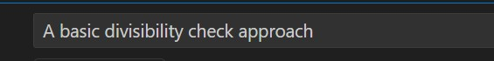

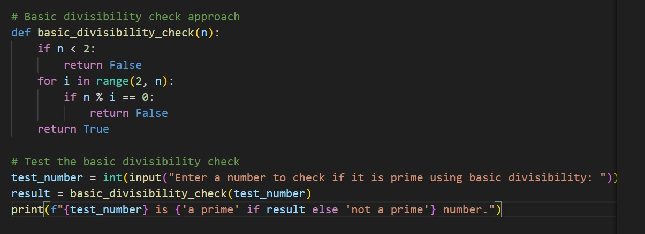

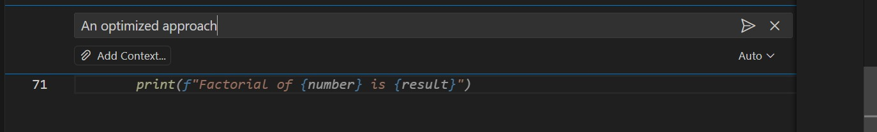

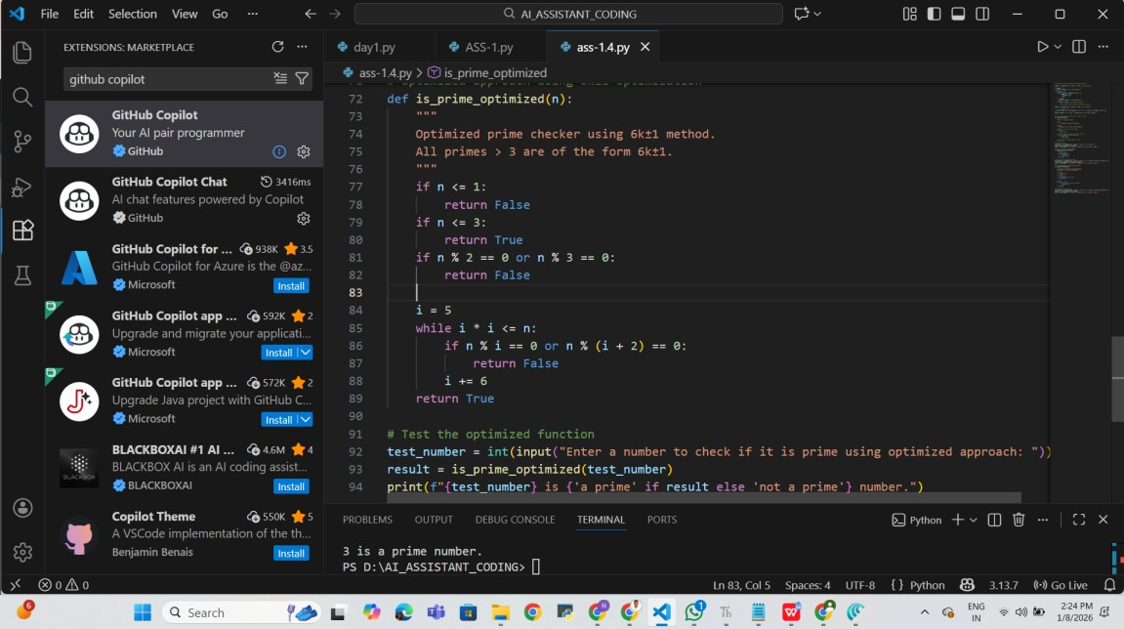

Comparison (Short Notes) Execution Flow:
Basic divisibility: Checks all numbers from 2 to n−1 sequentially.
Optimized (√n): Checks divisors only up to √n and stops early if a factor is found.
Function-based: Same optimized flow but wrapped in a reusable function.
Time Complexity:
Basic divisibility: O(n)
Optimized (√n): O(√n)
Function-based optimized: O(√n) Performance for Large Inputs:
Basic approach is slow and inefficient for large numbers.
Optimized approaches are much faster and suitable for large inputs.
Function-based version performs the same but is cleaner for repeated use.
When Each Approach Is Appropriate
Basic approach: For learning and very small inputs.
Optimized approach: For efficient single checks.
Function-based approach: For structured programs and multiple prime checks.

